**Fixed Challenge Script**

1) Introduction

**Qui :** Charles

**Où :** Pavillon Lassonde, biblio ou étage bleu, avec belle luminosité

**Points importants :** PolyCortex, forces de l’équipe électronique et informatique, carte avec filtrage analogique pour réduire le temps de traitement des signaux numériques, etc.

*Charles, le narrateur. Il est debout et avance tranquillement en parlant.*

**Charles:** « Ici Charles Bélanger Nzakimuena, directeur des communications à Polycortex. Welcome to our neurotechnology society. »

*Petite intro musicale avec la présentation du logo de PolyCortex. Retour à Charles.*

*(Présentation de l’équipe)*

**Charles:** « PolyCortex was founded two years ago and now brings together over thirty neurotechnology enthusiasts studying engineering at Polytechnique Montreal. As a student group, we combine our knowledge and creativity and pursue activities that involve the acquisition, processing and analysis of signals from the brain in order to develop tangible and practical applications. Our interdisciplinary teams are organized into three areas of expertise which consist of design, computer and electronics engineering. »

*(Présentation du projet)*

**Charles:** « Our submission to the NeuroTechX 2018 fixed challenge aimed at meeting all of the competition requirements, and exceeding expectations wherever opportunity arose. Inspired by available open source projects and leveraging software provided by our sponsors, we designed a printed circuit board (PCB) featuring surface-mounted technology and four channels for biosignal inputs. Our circuit is optimized to gather electroencephalography (EEG) signals using electrodes, and provides analog filtering and amplification. The connection of the circuit to a raspberry pi computer allows wireless communication with other devices and to our Python-written application. Through the application, real-time data can be visualized and recordings stored for further analysis. »

**Charles:** « Let's take a look on our project, with a live demonstration, a complete explanation of our acquisition pipeline and the presentation of our system’s main features! »

*Changement de plan.*

2) Démonstration live du projet

**Qui :** Andréanne et/ou Dina et Charles (cobaye)

**Où :** Pavillon Lassonde, 5ième étage, Local M-5502 pour afficher l’interface sur un grand écran ou mieux : **on loue une salle à la biblio toute la journée pour ne pas être dérangé!**

**Points importants :** Présentation et affichage des signaux avec acquisition sur une personne.

*L’interface est affichée sur le grand écran. Charles (cobaye) est assis et connecté à notre circuit d’acquisition. Andréanne et Dina vont expliquer le fonctionnement.*

*(Explication technique du fonctionnement pendant la démonstration).*

*Pendant les explications, on voit des plans de la carte soudée. Autres images pertinentes si nécessaire.*

*Figures 1, 2, 3 -> Présenter sur le vidéo en montage pendant les explications. (Si possible ajouter les cercles au fur et à mesure des explications).*

*Le restant du plan, on voit Charles connecté au circuit et les résultats apparaissant sur l’interface. On entend les voix de Dina et Andréanne avec quelques plans les montrant parler.*

*Andréanne et Dina se réfèrent à Charles et au circuit pendant leurs explications. Les explications seront également complétées par les informations plus techniques présentées plus bas.*

**Dina:** « EEG signals are captured on the head surface and are typically very small in peak-to-peak amplitude, ranging from as little as 5 μV to 300 μV. As a result of the small intensity of signals which originate from the activity of neurons, our acquisition PCB is designed to amplify its input several folds. To ensure a good signals reading, our design’s stages offer a combined gain of approximately 18000. In addition to the need for increasing the strength of the signal, the EEG recorded activity of neurons is rhythmic and our PCB is selective to a range of frequencies typically associated with mental activity, which is 0.5 to 35 Hz. »

**Andréanne:** « As can be seen on our board and as the schematic of our design will show more clearly, the signal coming from electrodes for each channel is first amplified through an instrumentation amplifier. Consequently and as we can see *(on Charles)*, the circuit contains 5 electrodes and each of the 4 signal channels refers to the reference electrode. Notice that for convenient design and test reasons, the reference electrode and the bias electrode are the same. In future work, we will ensure to separate them in order to improve the flexibility of the EEG acquisition circuit. For the demonstration, we choose to place two electrodes on each side on the head (on verra ici ce qu’on fait précisement)., all signals then travels through low and high pass analog filters to keep only the frequency band of interest. A notch analog filter then removes the 60-Hz power-line frequency interference. The signal is further amplified before it is directed to an analog-to-digital converter that connects to a raspberry pi computer over its I2C protocol. The raspberry pi runs our data processing program, which provides real time signal processing capabilities. Reading 4 channels simultaneously, we reach an acquisition rate of XX Hz. Through the interface we can visualize real-time signals in the time and frequency domains, and for each acquisition channel. »

*If we are able to demonstrate the detection of alpha waves, we do it at this moment in the video.*

*If not, we justify the fact that the obtained signals seem to be good -> Frequency range with FFT*

*Alpha waves (8-12 Hz): Elles sont produites lorsque le patient a les yeux fermés. Lorsque les yeux sont ouverts, il n’y aura pas de pic caractéristique dans la plage de 8-12 Hz.*

**Dina:** « As we can see, our acquisition pipeline is working well! Indeed, the obtained signals seem to be good in regard of the frequency range observed. Remember that the EEG signals are mostly located between 0.5 and 40 Hz. We also observe *talk about artifact and noise.* ».

**Dina:** « Our acquisition board possesses a protection circuit to prevent high leaking current to go from the board to the user and conversely from the user to circuit’s components.The board is powered with the 5V – GND potential difference generated by the Raspberry Pi. In order to use only this voltage source to power all of our components, a virtual ground is centered at 2.5V. With this virtual reference, a voltage shift to -2.5V and 2.5 V values occurs allowing us to properly power all of our op-amp integrated circuits.

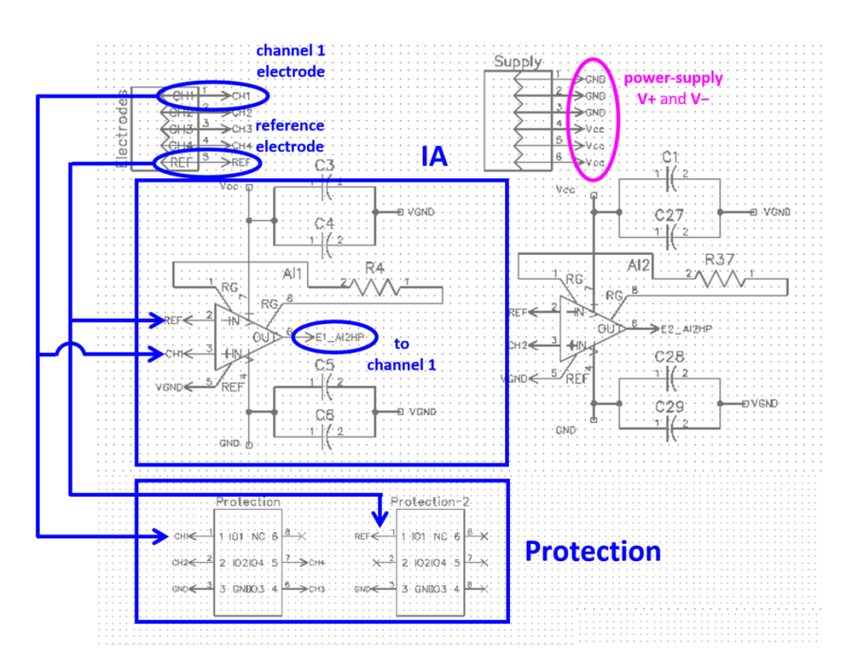

**Figure 1**

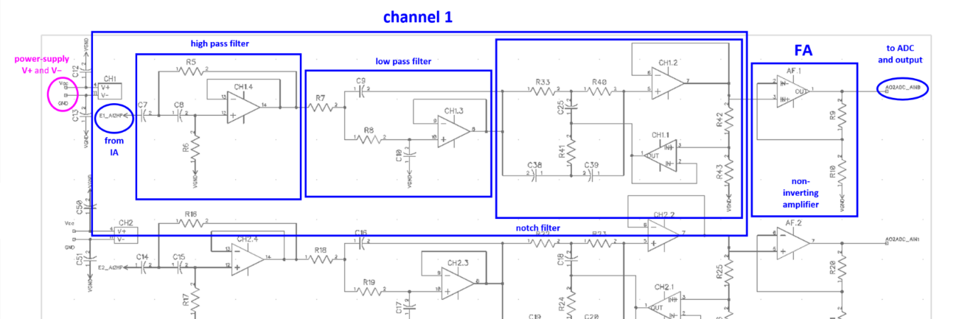

**Figure 2**

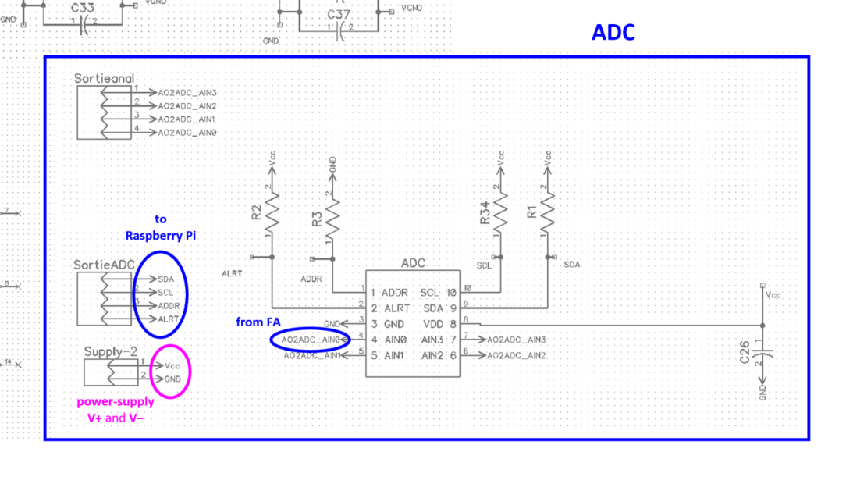

**Figure 3**

*Explication plus en détails du pipeline.* *Explication des choix de conception.*

*Dina et Andréanne toujours. Présentation du layout pendant qu’elles parlent et autres plans sur le circuit. Les informations ci-dessous sont très complètes et peut-être pas toutes nécessaires. Elles serviront à compléter la description pendant la démonstration.*

**[Design Software]** The LTSpice freeware was used to perform electronic circuit simulations, towards the selection of equipment and circuit troubleshooting.

**[Electrodes]** Our design uses reusable EEG electrodes. A unipolar EEG electrodes configuration was selected, which means that the potential from each channel electrode is compared to a reference electrode.

**[PCB]** Our PCB was drafted using our sponsor DipTrace’s software suite, which conveniently offers schematic to PCB layout conversion.

**[IC Chips]** The PCB features several chips (Figure 4) to achieve proper circuit protection, amplification, filtering and analog-to-digital conversion.

* First there are circuit protection chips (model TPD4E1B06DCKR by Texas Instuments) which are located right after the electrode input pins. Those circuits provide protection against electrostatic-discharge events.
* For each channel, the instrument amplifier integrated circuit (model AD620ARZ by analog devices) is configured to achieve a gain of 885. An additional amplifier chip (model LM324DT by STMicroelectronics) brings the total gain to approximately 18000. The gains allow the small signal (5 μV to 300 μV) to be amplified (90.7 mV to 5.442 V) and meet the downstream analog-to-digital converter voltage input requirements.
* The low and high pass analog filters have a Sallen-Key configuration and cutoff frequencies of 0.3 and 35 Hz respectively. The cutoff frequencies were selected to encompass most wake and sleep states of mental activity. The low and high filter ampli-op are contained in the same chip as those of the notch filter. The chip is the same model (model LM324DT by STMicroelectronics) as the added gain amplifier chip.
* Finally, the analog-to-digital converter chip (model ADS1115 by Texas Instuments) receives the amplified and filtered analog biosignals, and converts them to digital signals. The chip was chosen for its high 15 bit precision, its sampling rate capability, because it is well suited to sensor measurement applications, and for its ease of use with the Raspberry Pi using its I2C communication bus (the component has a precise internal clock).

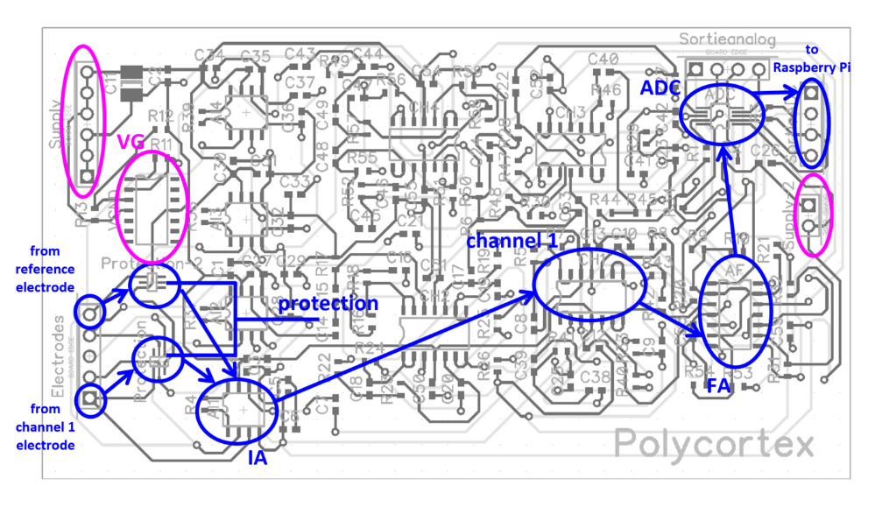

**Figure 4**

**[Resistors and Capacitors]** Surface mount resistors and capacitors were used throughout our PCB.

**[Visualisation of signal]** The adafruit website provides python code and gives detailed instructions on how to obtain real-time visualisation of ADS1115 analog values on a Raspberry Pi terminal. Having collected and analyzed the real-time data, we can demonstrate the alpha mode after closing of the eyes and a state of wakeful relaxation is achieved.

**[Power supply & virtual ground]** The board is powered with the 5V – GND potential difference generated by the Raspberry Pi. In order to use only this voltage source to power all our component, we used to create a virtual ground centered at 2.5V.With this virtual reference, we get -2.5V and 2.5 V values and this allows us to properly powered all our op-amp in differential way.

3) Caractéristiques du produit

**Qui :** Johnny ou autre membre (pour voir diversité dans les membres!) (et Charles?)

**Où :** Pavillon Lassonde, Laboratoire de génie électrique

**Points importants :** Taille, fonctionnement, prix, avantages/inconvénients, et autres petits détails importants à mentionner!

*Ici, on tourne quelques plans en laboratoire de génie électrique. Le but est de montrer un membre au travail (avec un breadboard pleins de fils pour faire de la frime) et qui va présenter les main features de notre carte d’acquisition.*

*Entrecoupé de plans montrant le membre testant le circuit avec l’oscilloscope. On pourra aussi réutiliser des plans de la vidéo explicative qu’on avait tournée avec la tablette de Charles avant les fêtes.*

**Jonny:** « Actually, the system we made is working well : the acquisition card is able to get EEG signals from the head surface, amplify and filter them and send them to a raspberry pi for processing. We believe that filter the signals in analog domain is an advantageous features for future precision work and concrete application. Indeed, the digital filters we added in our program are there to complete and ensure an almost perfect filtering. Also, we design our PCB using surface-mounted technology to improve the size of the card and to improve the SNR of the signals. The data processing code succeeds in reading simultaneously the 4 channels and then permits the real-time data visualization and processing».

*Présenter la figure 5 dans le montage vidéo.*

**Jonny:** « The total cost of our our home-made acquisition board with all of its components (Figure 5) is $76.10, which is far below the $1000 limit. By far the highest cost is the instrumentation amplifier which takes up more than two thirds of our total costs. While other integrated circuits contributed to our spending, they were not nearly as expensive. From a financial feasibility perspective, the construction of our PCB is quite accessible. »

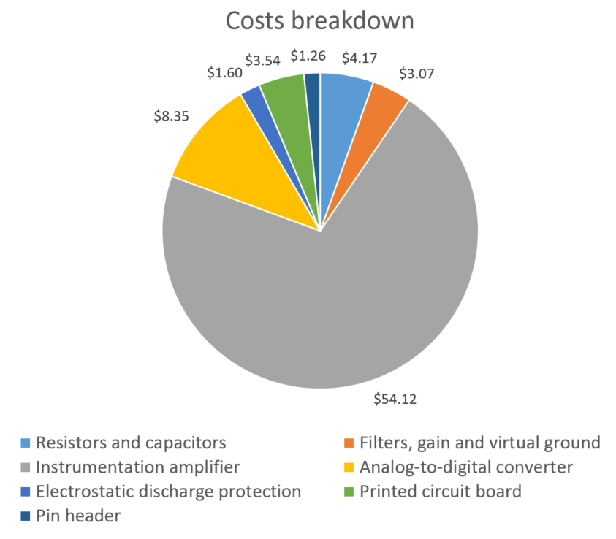

**Figure 5**

**Jonny:** « Also, our circuit is small, AA x BB cm, and can eventually easily fit on a headset. The size could also be improved in future work; the design we made was initially for convenient testing. By now, using our acquisition card and our processing code is quite simple. One can simply connect the electrodes (dry or with conductive paste) on a subject, connect any computer by VNC to the raspberry pi (after installing the pipeline code on the raspberry pi, of course), and then visualize the signals on the interface! »

**Jonny:** « Another advantage of our card is its flexibility. By changing only capacitors and resistors values, it could become an acquisition board for any other physiological signal, like ECG. Therefore, the realisation of this project was very good to understand and experiment the better way to detect EEG signals. »

*Retour à Andréanne, Dina et Charles. Présentation plus complète de ce que fait le pipeline en python pour le processing. Sur la vidéo on présentera un organigramme du code.*

**Dina:** « The pipeline code is able to … *We are able to detect alpha waves or we will add alpha wave mode – discuss the pipeline* »

**Andréanne:** « *Limitation and future work* – what could and would be improve ».

5) Conclusion

**Qui :** Charles

**Où :** Pavillon Lassonde, biblio ou étage bleu

**Points importants :** Lessons learned, biggests challenges,

*On est de retour avec Charles, seul, pour la conclusion. Bref retour sur l’ensemble du projet. Présentation des améliorations futures et des grands défis/problèmes rencontrés*

**Charles :** « Finally, in this project, we achieve the conception of a complete EEG acquisition pipeline, from electrodes to real-time data visualization. Our acquisition board allows 4 signals channel to be read simultaneously and our pipeline program permits parameters of interests’ extraction, as the presence of alpha waves by frequency analysis. »

**Charles :** « As a student group, we strongly valued the opportunity to draw from classroom and many other experiences, and to gain a true appreciation of the fundamental knowledge behind EEG applications. PolyCortex members faced some important challenges and learned lots by doing this project. Looking back, some may be surprised to learn that one of the tallest hurdles to our design was establishing proper powering of all of our PCB components using only a 5V source. We developed a precise virtual ground to help us in this way. The other difficulties we encountered included determining the implications of our reference electrode versus our bias electrode; fully understand the theory was not quite simple for everybody! But we took our time, read a lot, and finally produced a system that each PolyCortex member understands well. Another big challenge was to remove and also the efficient analog removal of 60 Hz interference, which will benefit from future improvements to our design.

**Charles:** «This project was complex, but simple at the time. The concept is simple, but its realisation requires a complete understanding of the EEG acquisition theory and concrete electronic and informatics application. In line with other open source initiatives which foster a thriving Neurotechnology community, we are excited to have made available on our GitHub repository, all resources which would allow anyone else to recreate our project (see the link at the bottom of the screen). »

**Charles:** « To advance science is a great privilege to any engineer. At PolyCortex, we show you that there is more than one way of using your brain to do so. Thank you and stay tuned for improvements to our project and other endeavours in the near future! »

*Remerciements des commanditaires en image pour conclure la vidéo, de notre cinéaste et autre.*